EXPERIMENT - 6
NAME: PERIYA NAYAGAM M ROLL NO: 240701382

Experiment with different layouts and colour schemes for an app. Collect user feedback on aesthetics and usability.
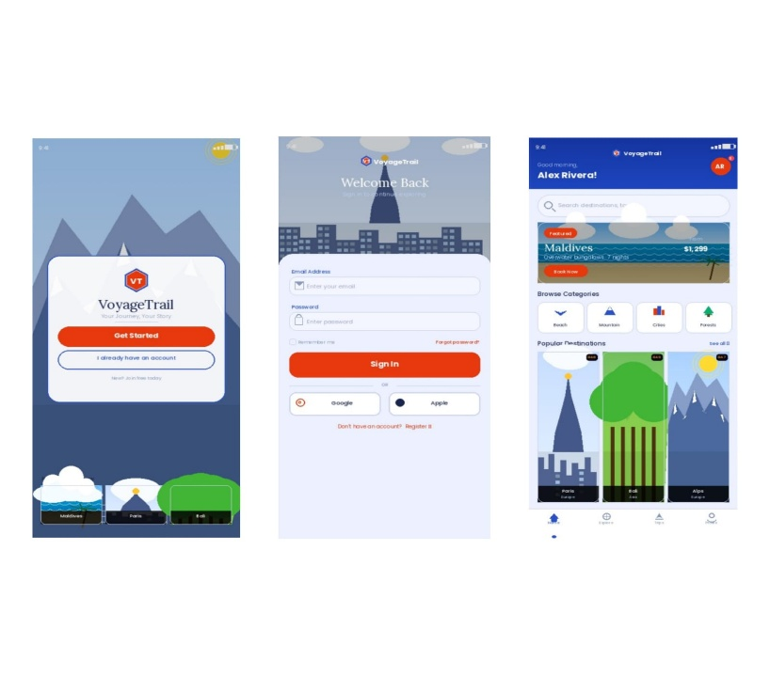
App Name
Voyage Trail (Travel App UI Design)

Light Mode Design
Description
Light mode is a user interface design where:
- Background is light (white / light blue)
- Text is dark for better readability
Characteristics
- Easy to read in daylight
- Clean and minimal appearance
- User-friendly for long usage
- Commonly used as default mode

Screens Designed
- Welcome Screen
- Login Screen
- Dashboard Screen

Design Details
- Background Colour: Light Blue
- Text Colour: Dark Blue / Black
- Buttons: Orange / Dark Blue
- Theme Feel: Simple, clean, and fresh
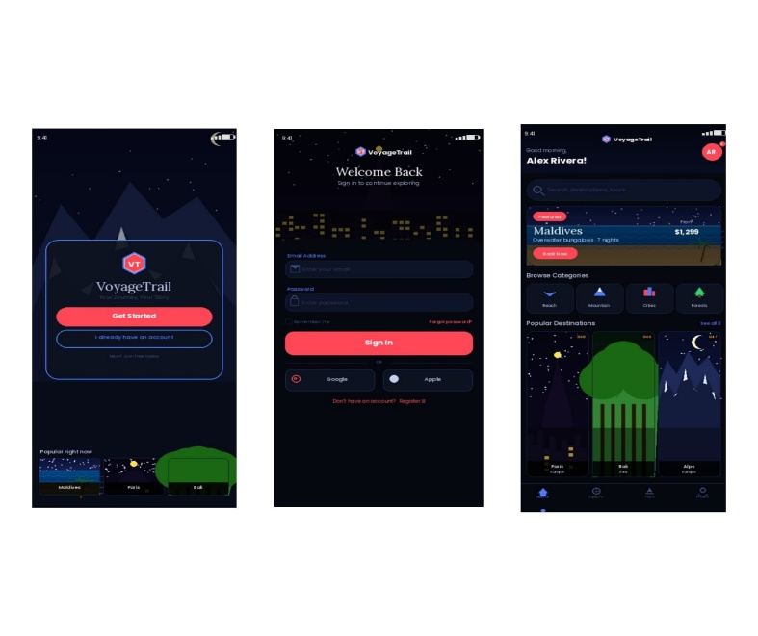
Dark Mode Design
Description
Dark mode is a user interface design where:
- Background is dark
- Text is light-coloured

Characteristics
- Comfortable in low light
- Reduces eye strain
- Saves battery (OLED screens)
- Gives modern and premium look

Screens Designed
- Welcome Screen
- Login Screen
- Dashboard Screen

Design Details
- Background Colour: Dark Blue / Black
- Text Colour: White / Light Blue
- Buttons: Red / Light Blue
- Theme Feel: Attractive, modern, and aesthetic .

Google Form

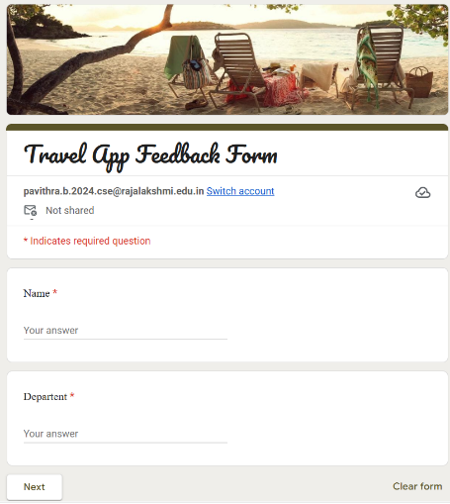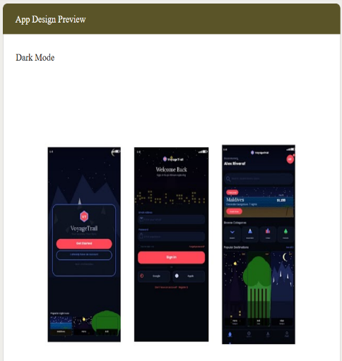
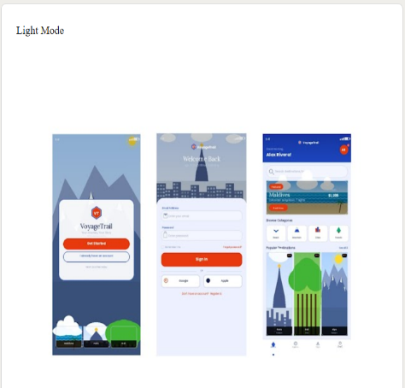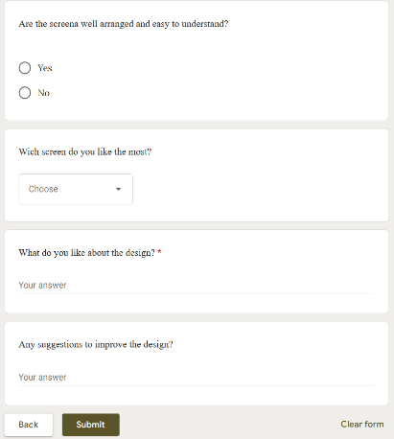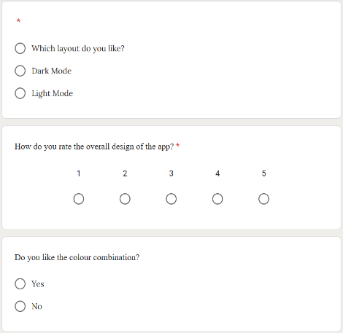

User Feedback Collection
A Google Form was created and shared with users to collect feedback about:
- Design appearance
- Colour preference
- Ease of use
- Suggestions for improvement

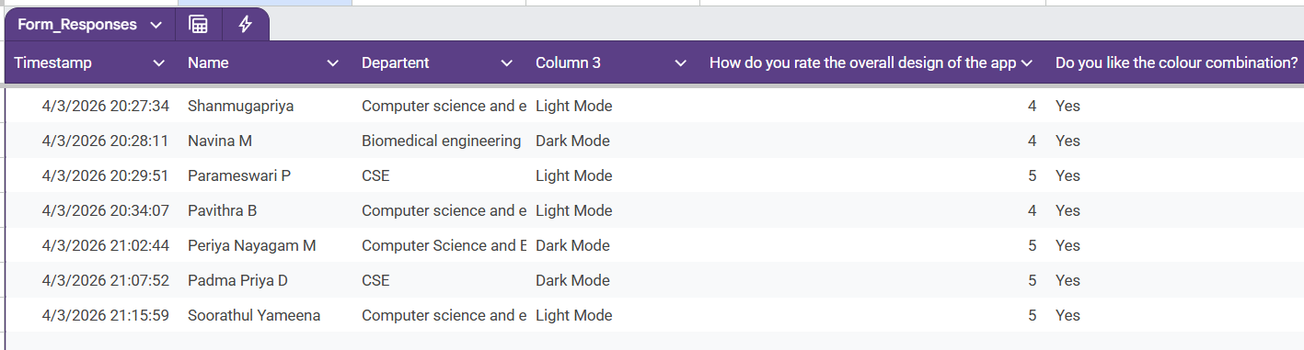

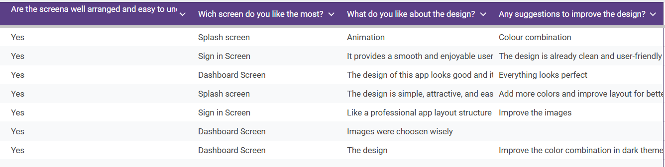

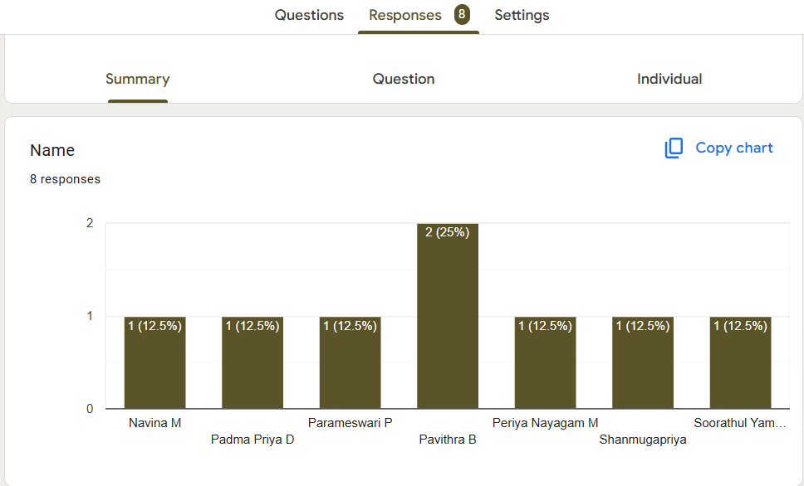

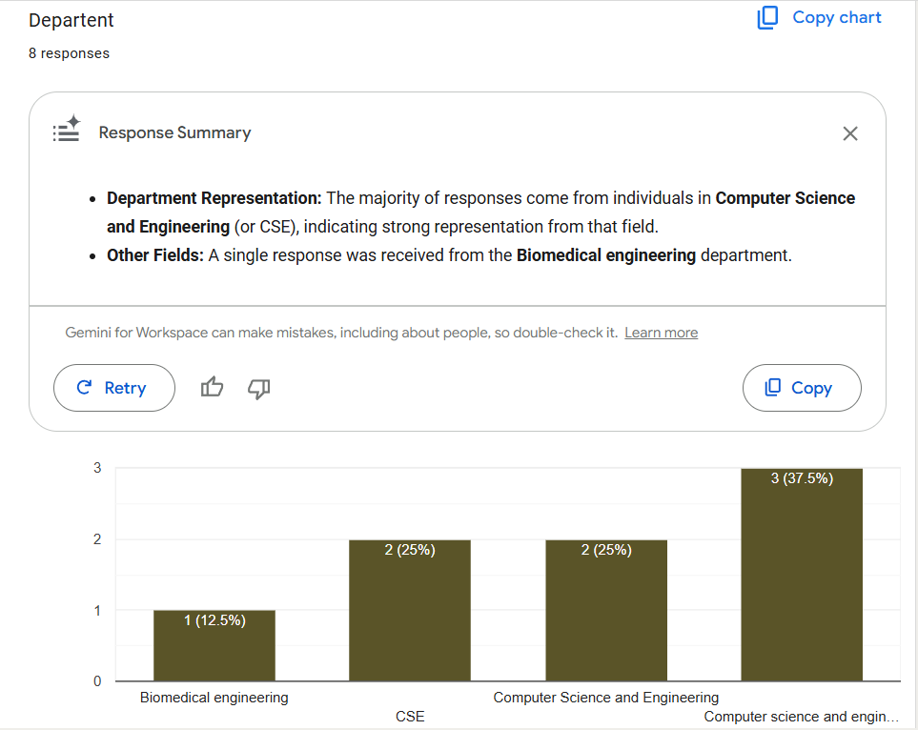

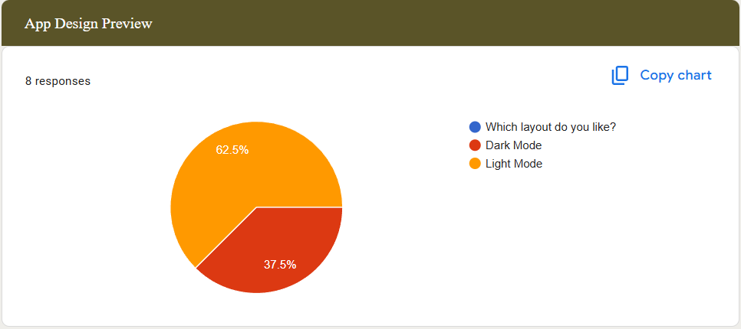

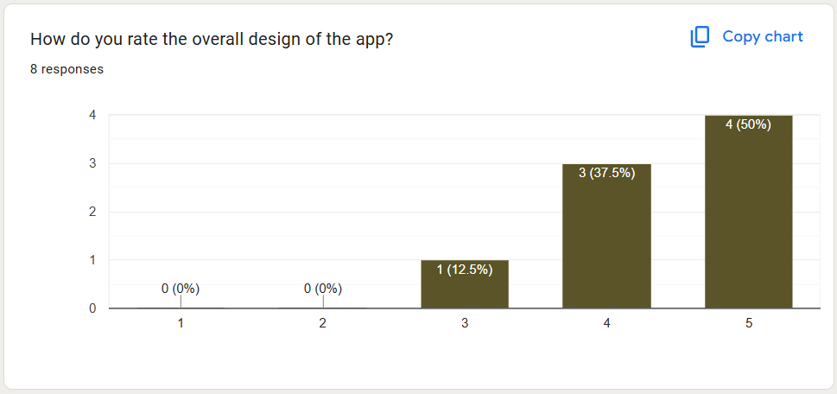

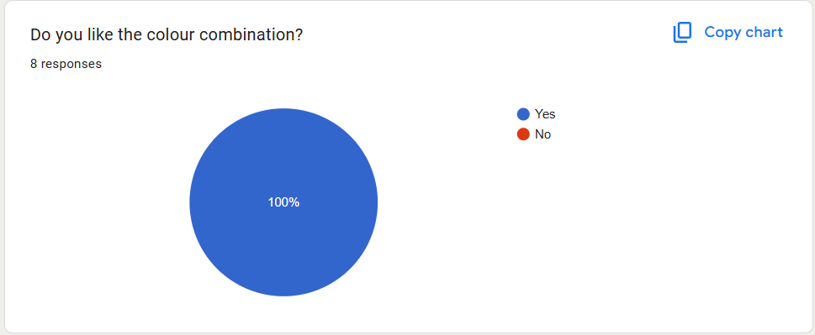

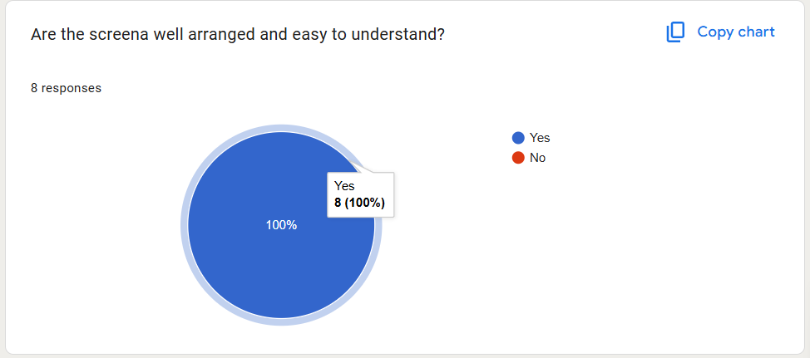

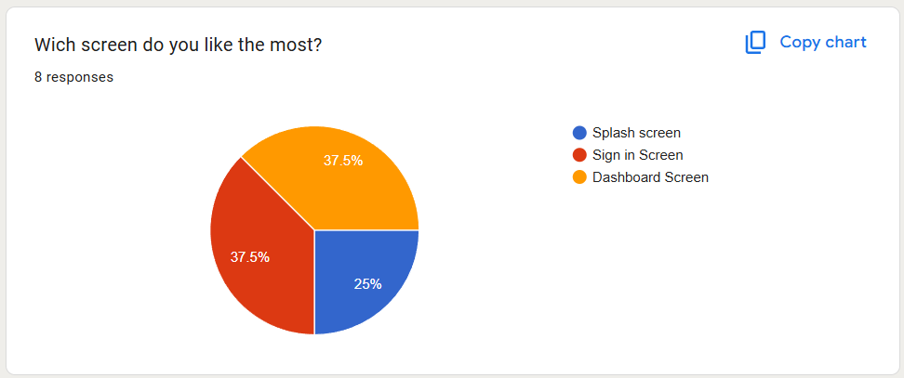

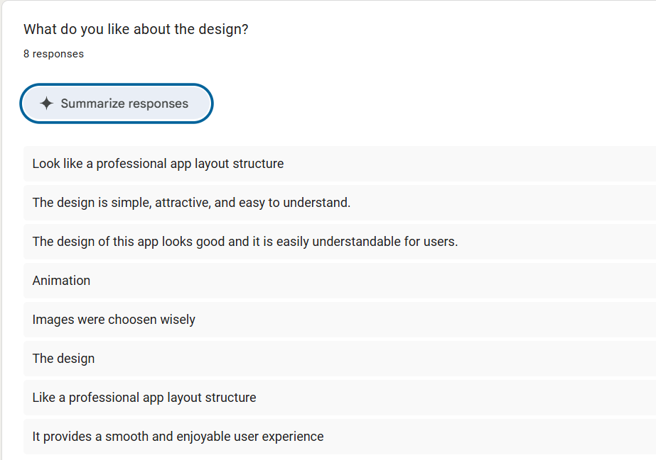

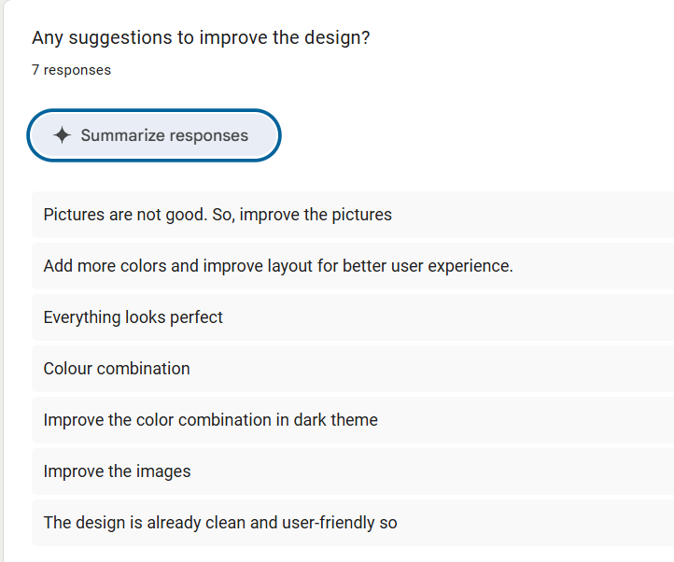

Inference
- Light mode is more popular among users
- The app design is visually appealing and user-friendly
- Minor improvements can be made in readability and spacing
- Overall, the UI design was successful and well-received

